Project Development Phase
ServiceNow Employee Analytics Test

Date | 30 September 2026
Team ID | SN-TRANSFORM-01
Project Name | Import Data using Transform Maps (Spreadsheet)
Maximum Marks | 4 Marks

ServiceNow Employee Analytics Test:
This report adapts the visualization template to validate the project’s ServiceNow reporting and dashboard narrative.
S.No. | Parameter | Screenshot / Values
1 | Data Rendered | Employee Test records and Transform History outcomes render in ServiceNow views. | Pass
2 | Data Preprocessing | Staging and transform steps preserve the values needed for reporting. | Pass
3 | Utilization of Filters | Department, Location and Employee ID filters behave consistently. | Pass
4 | Calculation Fields Used | Inserted, updated, ignored, error and total employee counts. | Pass
5 | Dashboard Design | Employee Analytics Dashboard presents concise operational summaries. | Pass
6 | Story Design | A reviewer can follow spreadsheet intake → transform → validation → reporting. | Pass

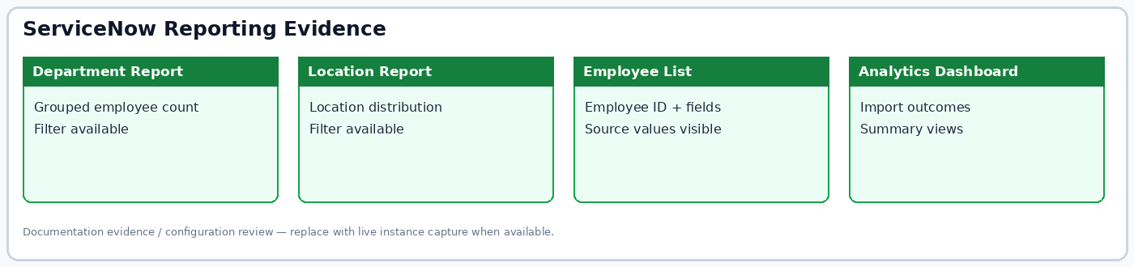
Figure: Project reporting evidence summary.

